Brainstorming - What features does the site need? What pages/areas and what about user auth?

User types

* Customer
  + Affiliation
  + Status: Active duty/ retired
  + ID card
* Manager (Scott & other employees)

Public pages:

* Home page (what can we put on the index?)
* Registration (register account)
* Login
* Terms and conditions
* Location/map
* Contact

Customer pages:

* Profile (user can update email/password/other personal information)
* New reservation (should we require the user to agree to the terms before making a reservation?)
  + Max stay between April 15 and October 15 is 14 days, then there’s a 14-day cooldown period before a customer can make a new reservation
  + Done only online
  + Online payment or in person payment
  + Shows availability
* Check-in page (Gives user information about amenities/wifi password??)
* My reservations/reservation history/receipts

Manager pages

* Daily report (show who is arriving, at what site, and for how many nights)
* Manage lots (type/size/name/price)
  + If smallest sized site for trailer isn’t available, give larger site
  + Temporary Dry storage site
* Manage site types (type name/price??)
  + List which RV lengths that site type can accommodate
* Manage amenities
* Manage peak times (?) holidays/special events

Special terms:

* Cancellations during holidays or special events will incur a 1-day charge (how do we know when it’s a holiday or special event?)

## 

## **General Information to Fill Site With:**

**✅Hours**:

Office Hours: 8:00 - 16:00

Check-in: After 13:00

Check-out: By 12:00

Quiet Hours: 22:00 - 8:00 (No Generators)

**✅Arrival:**

* HAFB South Gate: Fam Camp located 1 block west of South Gate.

**✅* Payments**: Payments can be made with Visa/MasterCard or cash in the office during regular hours. After-Hours arrivals must pay cash only and use the check-in booth located next to the office. Personal checks are not accepted.

**✅* Reservations**:

* Reservations can be made up to 6 months in advance and must be paid in full at time of reservation.
* Cancellations made at least 3 days before arrival will be charged a $10 fee. Cancellations made less than 3 days prior will be charged a 1 day fee. Cancellations for holidays or special events will be charged a 1 day fee.
* Maximum length of stay April-October is 14 consecutive days except for those traveling on PCS orders. Long term stays are allowed October 15th to April 1st. For detailed information, please contact the FamCamp office.

**✅**

**Postal Service Mailing Address:**

*Postal service mail need to be picked up at the Base Post Office Bldg 344*

Your Name

FamCamp

7338 Loncki St.

Hill AFB, UT 84056

**UPS and FedEx:**

*Parcels are delivered to the Office*

Your Name

FamCamp Bldg 564 Site #

5622 Park Lane

Hill AFB, UT 84056

**✅Amenities**:

* Rec Room:
  + Includes a microwave, dining area, TV lounge, study room, and book exchange. WiFi is available in or near the building. Stop by the office to check out our free DVD rentals
* Laundry:
  + Machines cost $1/cycle. Coin Machine is available in the Laundry Room. Please do not launder pet bedding or heavily soiled items in these machines.
* Ice:
  + Available in the Laundry Room free of charge. Please refrain from filling large ice chests.

**✅Guidelines**: In an effort to ensure compliance with all public health and safety requirements, RVs are subject to inspection when conditions observed from the exterior of the RV suggest a potential hazard or substandard condition exists within the unit. In the event of an inspection, all RV units must be able to demonstrate the following:

* Proper connection to the park’s fresh water system using the unit’s exterior water connection. The fresh water connection on the unit should be inspected to ensure it is leak-free and made of a material approved for potable water.
* Power cord and/or approved adapter is approved for RV use and maintained in a safe operating condition.
* The sewer drain connection on the unit must be gas-tight and leak-free. Hose must be constructed of minimum schedule 40 ABS plastic approved for drain and waste.

**✅Pets:** Leashed and vaccinated pets are welcome provided pet owners adhere to the following installation requirements:

* Animal waste will be picked up and properly disposed of immediately.
* Pets will remain on a leash in control of the owner unless in the designated dog park area.
* When using the dog park, the pet owner must be present at all times.
* Dogs will not be chained outdoors or left unattended at any time.
* In consideration of other guests, nuisance pet behavior will not be permitted. This is to include but not be limited to pets that display aggression and/or excessive barking.
* 2 Pet maximum.
* Dogs with any of the following breed lineage are restricted from FamCamp:
  + Pit Bulls
  + Staffordshire Terriers
  + Rottweilers
  + Chow Chows
  + Doberman Pinschers
  + Wolf Hybrids

**✅Parking:**

* Vehicles are only allowed to park in assigned spaces. Parking on vacant sites or roadways is not authorized. Please see Camp Host or Staff for information on overflow parking and visitor areas. Parking on grass is not permitted.

**✅Map:**

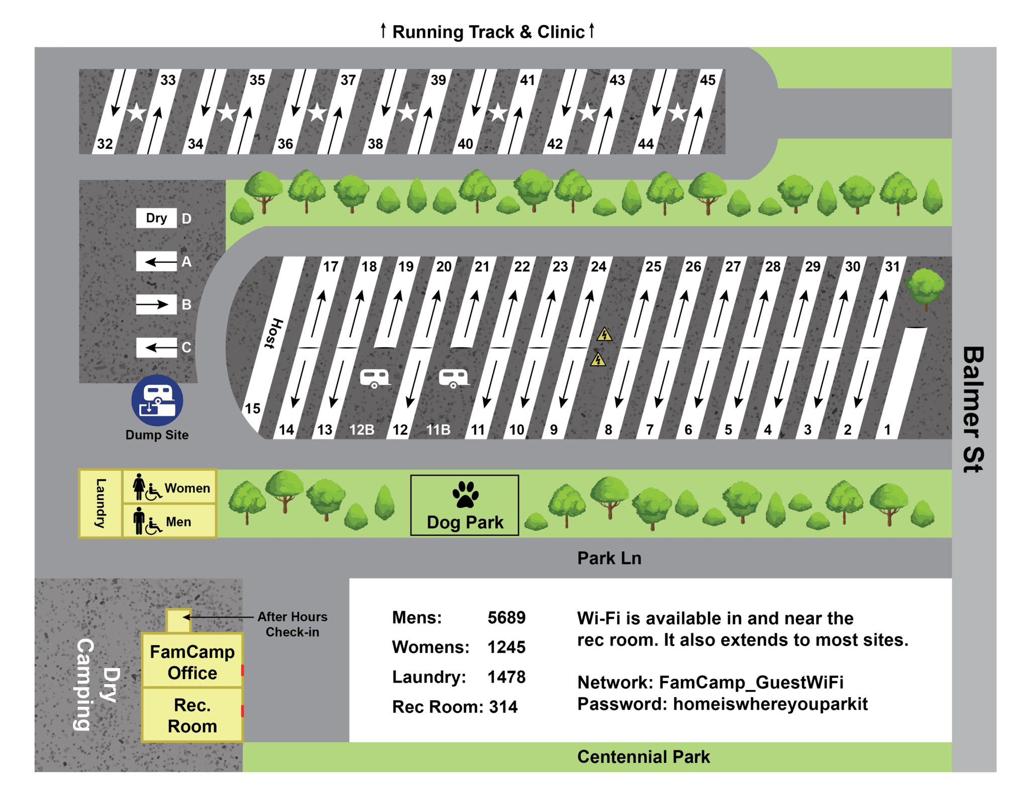

**✅Pricing:**

* Trailer Site: $25
* Tent Site: $17
* Storage: $5 ($30/week, $100/month)
* Dry Camping (No Hookups): $17
* Pop-Up Trailer: $30

**✅Trailer Site Sizing:**

* Sites 2-14: 42’
* Sites 17-31 (Excluding 19 and 21): 45’
* Sites 32-45 (Pull through. Top of Map): 65’
* Sites 1, 19, 21: 55’
* Pop-Up Trailers: About 4’ x 7’

## **Functional Requirements:**

Unregistered User:

* View Policies
* View Pricing/Availability
* Create an Account

Future Guest:

* Everything an Unregistered User can do
* Modify account information
* Make a reservation
* View Past reservations

Admin:

* Everything Future Guest can do
* Modify a reservation
* View all reservations, querying by day or guest if desired
* View all guests information
* View Availability, querying by day if desired
* Manage Site Information
* Manage Amenities
* Process Refunds

System:

* Can accept payments for all card types.
* Reservations:
  + Can Be Made up to 6 months in advance
  + Paid in Full at time of booking
  + 14 day limit between April 1 and October 31 (Exception: [PCS Orders](https://www.military.com/pcs/pcs-orders-5-things-to-do.html))
* Cancellations:
  + 3 Days Before Arrival: $10 fee
  + 2 Days Before Arrival: 1 day fee
  + Holiday/Special Events: 1 day fee
* View A List of Current-Day Reservations, As displayed by Figure 1
* View a List of Current-Day Site availability, As displayed by Figure 2

**Figures & Diagrams**

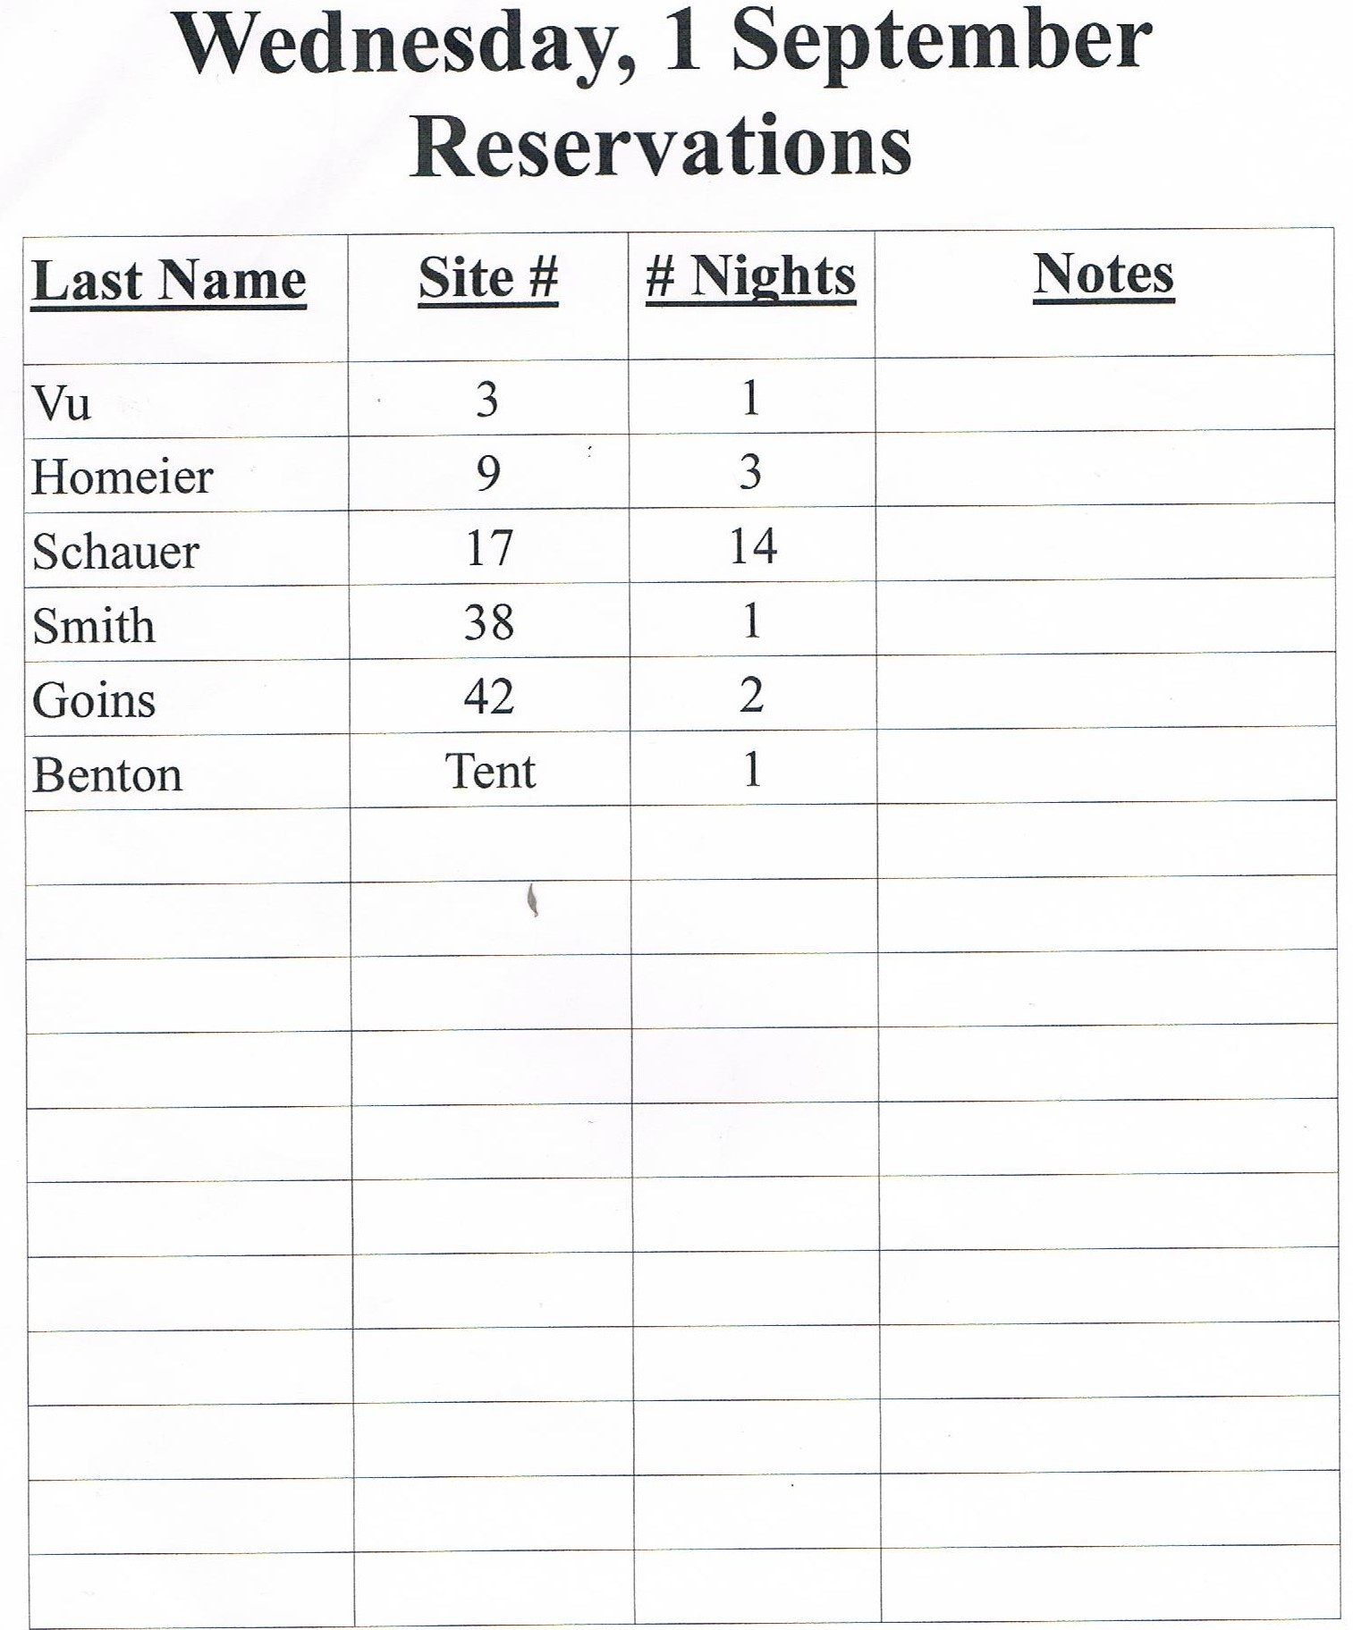

**Figure 1**

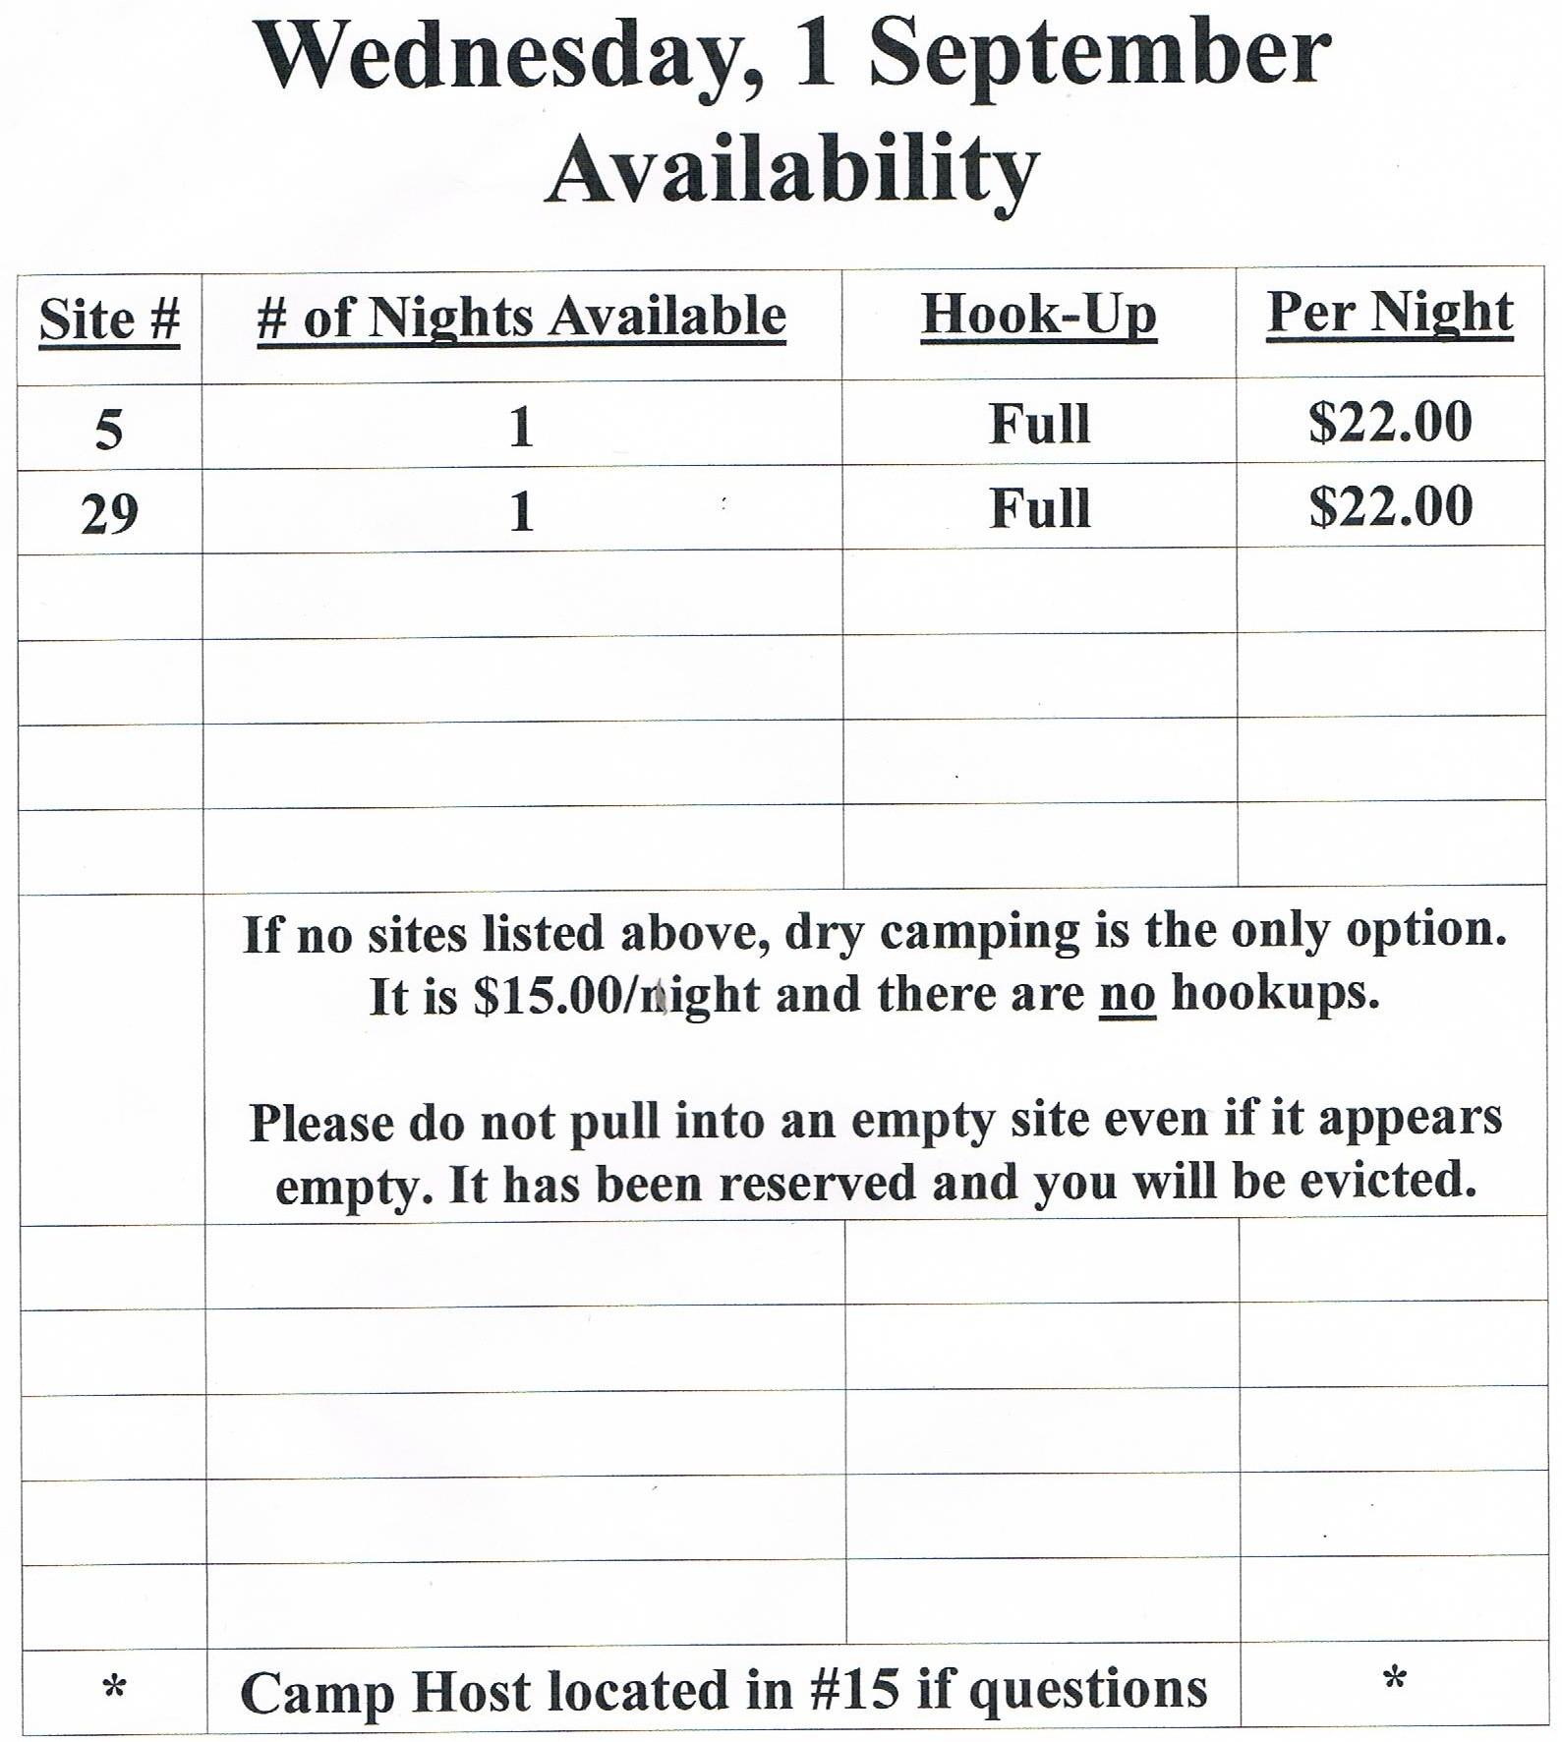

**Figure 2**

Questions:

* With the new system, are we able to implement after-hours card payments because it’ll be available online, instead of forcing cash payments?
* Are cash payments still an option, and if so, how would that be processed to still hold the reservation for the customer? Could we keep a credit card on record as a back up?